**PUSL3190 Computing Individual Project**

**Interim Submission**

Chemistry Lab for AL Students

Supervisor: MS: Dulanjali Wijesekara

Name: Leesa W Wimaladarma

Plymouth Index Number: 10899732

Degree Program: Software Engineering

Table of Contents

**Chapter 01 - Introduction** 4

**1.1** **Introduction** 4

**1.2** **Problem Definition** 5

**1.3** **Project Objectives** 6

**Chapter 02 - System Analysis** 7

**2.1 Literature Review** 7

1. Overview 1.1. Chemistry - What Is It? 7

1.2. Basic Ideas in Chemistry 7

2. Overview of Chemistry Education Platforms 7

3. The Value of Chemistry Education Applications 8

4. Integration of LMS with Technological Systems 8

5. Using Interactive Chemistry Learning with Educational Games 8

6. Virtual Labs for Improving Learning 9

8. Using Simulation to Teach Chemistry to Pre-Service Teachers 9

9. Increasing Involvement with Resources for Creative Chemistry 9

10. Thorough Integration of Technology-Enhanced and Interactive Tools 9

**2.2 Facts Gathering Techniques** 10

**2.3 Existing System** 11

**2.4 Use case diagram** 14

**2.5 Drawbacks of the existing system** 15

**2.6 UI Design Development** 18

**Using Shneiderman's Eight Golden Rules in My User Interface Design** 29

**Chapter 03 - Requirements Specification** 30

**3.1** **Functional Requirement** 30

**3.2 Non-Functional Requirements** 33

**3.3 Software Requirements** 35

**Chapter 04 Feasibility Study** 36

**4.1 Operational Feasibility** 36

**4.2 Technical Feasibility** 38

**Chapter 05 System Architecture** 40

**5.1 Class Diagram of Proposed System** 40

**5.2 ER Diagram** 41

**5.3 High-level Architectural Diagram** 42

**Chapter 06 - Development Tools and Technologies** 43

**6.1 Development Methodology** 43

**6.2 Programming Languages and Tools** 44

**6.3 Third Party Components and Libraries** 45

**6.4 Algorithms** 46

**Chapter 07 - Discussion** 49

**Summary of the Interim Report** 49

**Summary of the Report** 49

**Challenges Faced** 49

**Future Plans** 50

**References** 51

# **Chapter 01 - Introduction**

## **Introduction**

The education sector has been significantly impacted by the rapid pace of technological development, which has brought about new approaches to improving learning through interactive and digital media. Technology has enormous potential to provide more interesting and productive learning experiences for chemistry, a subject that was historically dominated by abstract ideas and hands-on laboratory work. Complex chemical ideas can be effectively learned with computer-based learning software that incorporates gamification aspects, interactive practice problems, simulations, and visual aids (Smith & Brown, 2021). It has been demonstrated that gamification improves motivation and engagement in educational settings by introducing components like points, badges, challenges, and prizes (Anderson & Miller, 2022).

This project's goal is to provide an engaging online chemistry curriculum that will benefit chemical experts, instructors, and students alike. A periodic table, a chemistry color search engine, a flame testing guide, science calculators, and gamified challenges and quizzes are just a few of the resources that will be available on the website. These will assist users explore chemical reactions, do simple calculations, and have a better grasp of chemical properties. Reading textbooks and going to lectures are two of the more conventional methods of studying chemistry, but they aren't always the most engaging or simple to understand. The website seeks to promote a more interesting and inspiring learning process by incorporating gamification techniques including progress monitoring, point systems, and real-time feedback (Johnson et al., 2023).

According to Jones et al. (2020), there is proof that online learning materials, especially those that use gamification, are improving student engagement, information retention, and self-directed learning. To meet these needs, the app features a gamified quiz system for instantaneous chemistry concept testing, an interactive fill-in-the-blank concept map, and an image gallery of the primary organic compounds. These features boost experiential learning by enabling users to assess their comprehension of key concepts and obtain immediate feedback or rewards, which has been demonstrated to increase motivation and retention (Williams, 2019).

The platform's security, usability, and accessibility are also important features. The web application will have a secure registration and login feature, guaranteeing users a unique educational experience. The modal picture zoom function will enable the user to closely inspect complex molecular structures and experimental data, and the adaptable navbar and footer will make it easier to navigate between the website's parts. According to research, virtual platforms that are well-planned and structured enhance learning efficacy by providing content that is well-guided (Williams, 2019). Research has shown that dynamic learning environments, especially those that use gamification, increase student engagement and comprehension as technology redefines education (Anderson & Miller, 2022).

The goal of the project is to close the gap between theory and practice by utilizing the newest web development tools, including HTML, CSS, and JavaScript. To teach chemistry in an engaging and efficient way, the objective is to develop an educational and user-friendly portal. This web application offers a helpful and practical platform that enables students with various learning requirements to learn chemistry more conveniently and engagingly, which is in line with the growing trend of using e-learning for STEM education. This program is an equally valuable learning tool for today's technologically advanced environment thanks to its interactive features that improve self-testing, real-time experimentation, and gamified learning modules (Johnson et al., 2023).

## **Problem Definition**

Chemistry is a fundamental scientific subject that necessitates a solid grasp of theory, real-world applications, and experimental techniques. Because they lack interactive components and practical experience in the subject of chemistry, traditional teaching methods such as textbook study and class lectures frequently fail to engage pupils. Because chemical concepts are sometimes abstract and there aren't many resources available that are presented in an interesting, interactive way, they might be difficult to understand.  
Furthermore, students frequently lack access to lab experiments, the main means of studying chemical characteristics and reactions due to institutional restrictions, safety concerns, or a lack of resources. Knowledge gaps could result from depriving students of the experiential learning they require. A thorough grasp of chemistry requires the development of critical problem-solving and analytical abilities, both of which can be hampered by this problem.

Students' capacity to actively connect with the subject is limited by the lack of digital and interactive learning tools as well as the absence of gamification aspects in existing platforms. By adding game-like features like challenges, prizes, and progress tracking, gamification has been shown to be a successful strategy for improving motivation, interaction, and learning retention (Johnson et al., 2023). Current chemistry study aids are less successful at encouraging student engagement and information retention because they are frequently disjointed, interactive, or do not incorporate gamified elements.

This project suggests creating an interactive chemistry web application that incorporates gamification strategies and necessary learning resources in order to solve these issues. Among the application's primary features will be –

* Students can receive points for correctly identifying elements and their qualities in an interactive periodic table that is available online. They can also win achievements for discovering new elements.
* With timed challenges to test and enhance speed and accuracy and rewards for finishing tasks, this chemical color search function allows users to identify substances based on their color reactions.
* Students can practice flame tests, earn badges, and monitor their progress in learning identification skills with this guide to flame tests that help them identify components by their flame colors.
* Chemistry-based equations and conversions can be solved with scientific calculators that include gamified problem-solving activities that provide students with instant feedback and incentives for right solutions.
* A picture gallery, concept maps, and quizzes are used to reinforce learning. Gamified quizzes provide badges for finishing challenging topics or reaching new levels, as well as point systems and real-time feedback.

To create an effective online learning environment, usability, accessibility, and security are also essential. An adaptable design will guarantee that consumers can access and interact with information on a variety of devices, and a secure login and registration system will offer a customized experience. Students will be encouraged to keep researching and learning chemistry concepts by including gamified features like leaderboards and achievements into the classroom.

This project will provide an engaging, interactive, and gratifying learning experience using contemporary web technologies including HTML, CSS, and JavaScript on the front-end and Java and MongoDB on the backend. For students, instructors, and professionals, gamification will improve the learning process, boost user engagement, and close the gap between theoretical chemistry instruction and real-world applications, making chemistry more engaging, approachable, and productive.

## **Project Objectives**

* Determine Organic Compounds and Transformations - To improve comprehension, give students the opportunity to recognize organic transformations, catalysts, and products through an interactive visualization method.
* Enable pupils to realistically conduct light tests and recognize the hues of anions, cations, and compounds by simulating chemical tests and identifications.
* Interactive Study Materials - To assist students in remembering important chemical reactions, catalysts, and characteristics, provide them with interactive materials such as periodic table and reaction summaries.
* Calculating Chemical Properties - Provide students with interactive resources and calculators to aid in their analysis of chemical reactions and properties for a better understanding.
* Reflection and Self-Evaluation - To gauge and monitor students' development and retention of knowledge, promote self-evaluation through tests, questions, and quizzes.
* Encourage Tailored Learning Paths - Give students the freedom to design their own study plans and select materials according to their learning requirements to improve retention and mastery.
* Gamification - Incorporate game-like features like leaderboards, points, badges, and unlocked achievements to boost student motivation, engagement, and platform interaction. This will motivate students to finish assignments, push themselves, and monitor their progress through a variety of entertaining and rewarding mechanisms.

# **Chapter 02 - System Analysis**

## **2.1 Literature Review**

1. Overview  
  
1.1. Chemistry - What Is It?  
  
The study of matter's composition, structure, characteristics, and reactions is known as chemistry. Since it gives answers to real-world issues in engineering, medicine, and the environment as well as the foundation for comprehending many natural phenomena, it is typically seen as a foundational science. Inorganic chemistry, organic chemistry, physical chemistry, analytical chemistry, and biochemistry are some of the subfields of chemistry. Students generally concentrate on inorganic and organic chemistry in their G.C.E. Advanced Level coursework.

Inorganic compounds, which mostly consist of metals and minerals, are the subject of inorganic chemistry. Students should be aware of color tests, flame tests, and reaction predictions when studying inorganic chemistry. Conversely, organic chemistry deals with substances that include carbon and necessitates an understanding of catalysts, reaction mechanisms, and their functions in chemical processes.

1.2. Basic Ideas in Chemistry  
  
Concepts of Inorganic Chemistry -

* Color, Anion, and Cation Identification - Color charts, precipitation processes, and flame tests are used to distinguish between various ions.
* Component analysis is a technique used to ascertain an inorganic substance's composition.
* The lamp test is a qualitative analysis technique that uses flame colors to identify specific ingredients.

Concepts of Organic Chemistry –

* Understanding molecular interactions during chemical transformations through reaction mechanisms.
* Investigating how catalysts quicken chemical reactions is known as catalysis.
* Analyzing how functional groups affect the behavior of organic molecules is known as functional group analysis.
* Simple Quiz - This brief interactive test serves to reinforce important ideas in organic chemistry.
* Conceptual Diagrams - To improve comprehension, these visual aids depict organic reactions, functional groups, and mechanisms.

2. Overview of Chemistry Education Platforms  
  
Numerous interactive chemistry tools have been created to aid in learning because of the growing significance of technology in education. They consist of chemistry-based calculators, interactive periodic tables, and reaction simulators (Hassani & Jafari, 2021). Nonetheless, a significant obstacle is the absence of

platform integration, which forces students to navigate between several tools to obtain the information they need (Berthet et al., 2020).

3. The Value of Chemistry Education Applications  
  
  
Students' engagement and comprehension are greatly improved by educational applications, especially in abstract disciplines like chemistry. Hwang et al. (2018) claim that through individualized learning experiences and real-time feedback, technology-enhanced learning environments boost motivation and conceptual understanding. By making abstract ideas more approachable, these apps raise student achievement.

The following are essential components of a successful instructional chemistry application –

* Students can more easily distinguish between elements and compounds by using color identification.
* Organic Chemistry Catalyst Information: Offers thorough descriptions of catalysts and how they function in chemical reactions.
* The interactive periodic table shows the properties, relationships, and practical uses of the elements.
* Calculator for Problems Using Chemistry helps with calculations involving stoichiometry, molarity, and other chemistry principles.
* An intuitive user interface improves learner engagement and navigation.

## 4. Integration of LMS with Technological Systems

There are several advantages of using Learning Management Systems (LMS) into chemistry instruction, such as –

* Smooth Access to Educational Resources - Learning management systems (LMS) offer organized access to educational resources.
* Data analytics - Learning management system (LMS) systems monitor student interactions and provide information for tailored learning interventions.
* Support for Mobile Learning - Platforms that are optimized for mobile devices consider the learning patterns and preferences of students.

5. Using Interactive Chemistry Learning with Educational Games  
  
A successful strategy for increasing student interest in chemistry is gamification. To teach high school pupils about elements, compounds, and the periodic table, Bayir (2014) created three chemistry games - Groupica, Compoundica, and Elements. These activities enhanced conceptual knowledge and exam preparation, according to a study conducted at a Chemistry activities Day event with 250 students and 30 teachers.

In a study at Alasmarya Islamic University in Libya, the usefulness of Kahoot! for teaching chemistry was examined. At the conclusion of three modules, a sample of thirty first-year pharmacy students took Kahoot! quizzes. The efficiency of gamification in chemistry instruction was demonstrated by the results, which showed greater comprehension of molecular weight concepts and increased student engagement. Additionally, the study emphasized the advantages of anonymous participation, which promoted increased student involvement.

6. Virtual Labs for Improving Learning  
  
It has been demonstrated that virtual labs enhance student engagement and learning results in chemistry classes. Despite maintaining their technical lab skills, Alhashem and Alfailakawi (2023) discovered that students who were exposed to virtual labs showed greater enthusiasm in chemistry experiments. Through interactive exploration, virtual labs effectively augment conventional teaching techniques, improving conceptual understanding.  
  
7. Organic Chemistry Learning via Context  
  
Students' capacity to connect chemical concepts to practical applications is enhanced by context-based learning, or CBL. Hanson (2023) discovered that when learning subjects like additional reactions and molecular structures, pupils exposed to CBL had enhanced thinking and problem-solving abilities. This method makes difficult chemistry subjects more relevant.

8. Using Simulation to Teach Chemistry to Pre-Service Teachers  
  
Future chemistry teachers benefit from simulation-based teaching techniques like Situational Simulation Teaching (SST). Hanson (2023) claims that SST offers role-playing exercises that enhance professional abilities in classroom administration, instruction, and communication. SST enhances educators' readiness for teaching careers by mimicking authentic laboratory and classroom environments.

9. Increasing Involvement with Resources for Creative Chemistry  
  
Cutting-edge chemistry tools, such as activity books, online tutorials, and coloring books with chemistry themes, aid in bridging the gap between theoretical understanding and real-world applications. According to Caspi et al. (2023), these materials help make chemistry more interesting and approachable for a wide range of students, encouraging critical thinking and increasing interest in the topic.

10. Thorough Integration of Technology-Enhanced and Interactive Tools  
  
The literature study emphasizes how technology is revolutionizing chemistry teaching. Virtual labs (Alhashem & Alfailakawi, 2023), educational games (Bayir, 2014), and context-based learning strategies (Hanson, 2023) all improve comprehension and engagement in different ways. While innovative resources increase accessibility and boost student engagement, simulation-based instruction helps aspiring teachers develop their professional skills.  
In particular, gamification has shown itself to be an effective strategy for raising learning results and student motivation. Improved memory and comprehension have resulted from the use of interactive tests, virtual experiments, and instructional games centered around chemistry. To help students successfully grasp difficult ideas, this study emphasizes the necessity of well-integrated and captivating teaching applications in chemistry.

## **2.2 Facts Gathering Techniques**

It is crucial to collect pertinent information and needs from instructors and students to create an interactive chemistry web application. When appropriate, gamification components are used in the following fact-gathering techniques

* Interviews - To learn about students' and teachers' expectations, difficulties, and learning needs, conduct interviews with them.

Get input on how well the current chemistry learning resources are working and pinpoint any weaknesses, such as how gamified elements like leaderboards, badges, and points could improve student engagement.

* Surveys and Questionnaires - Send out online questionnaires to instructors and students to get their thoughts on the features that are needed and the preferred methods of learning.  
  Ask specific questions on gamified features like quizzes, progress tracking, and accomplishment prizes to get feedback on the digital chemistry tools' usability, accessibility, and degree of involvement.
* Observation - Watch how students use textbooks, seminars, and lab sessions traditional chemical materials.

Determine how gamified features like timed tasks and incentives could enhance interaction with complex content. Identify the issues associated with visualizing chemical concepts and doing calculations.

* Document Analysis - Examine current teaching materials, including lab manuals, chemical textbooks, and online learning environments.  
  Examine scholarly studies on the usefulness of interactive teaching resources in chemistry classes, with a focus on how gamification can increase student enthusiasm and retention of information.
* Focus Group Conversations -To improve the system's features, arrange talks with educators and students.  
  Learn about the difficulties in teaching and studying chemistry and how gamification and other forms of technology might help. Pay attention to how pupils react to achieving badges, levels, and points for grasping important subjects.
* Prototyping - Create a simple application prototype to get early input on its functionality and usability.  
  Permit users to suggest changes by interacting with tools such as quizzes, calculators, and the periodic table. To measure student engagement and pinpoint areas for growth, specifically evaluate gamified components such as leaderboards, progress tracking, and interactive quizzes with real-time feedback.

To further enhance the learning process, chemical experts will contribute to future iterations of the app –

* Utilizing information of a professional caliber, including case studies, lab procedures, and advanced chemistry ideas.
* Granting access to previous exams, practical, study guides, and chemical problems to aid with research and test revision.
* To increase student and professional involvement, the gamification element is being expanded to include more complex level advancement, achievement badges, and expert leaderboards.

With consideration for the incorporation of gamification features to improve motivation and learning, this fact-gathering approach guarantees that the application is optimized for both teachers and students. To guarantee participation at all levels, the strategy also calls for future extensions that will include gamified components and professional-level materials.

## **2.3 Existing System**

Although there are many teaching and learning tools available for chemistry now, most of them lack the necessary elements to best support student learning and are not very engaging, inspiring, or comprehensive. The following are a few of the current teaching methods used in chemistry classes –

1. Conventional Textbooks

* Explanation - Basic chemical information can be found in books and products printed on paper.
* Limitations - Limited visual assistance and static material.  
   No immediate student interaction or input.  
   Inability to understand abstract ideas such as molecular structures or chemical operations.

2. Platforms for Online Chemistry

* Description - Chemistry lessons, videos, and activities are available on websites and platforms (such as Khan Academy, ChemCollective, and ChemGuide).
* Limitations - Some programs just provide video-based instruction; they don't include interactive exercises or real-time testing.  
   There is little emphasis on giving pupils practical experience, including lab simulations.  
   Resources are dispersed, making it challenging for pupils to locate what they require in a single tool.

3. PhET and other chemistry simulations

* Simple interactive chemical simulations are provided by certain technologies, such as PhET Interactive Simulations.
* Limitations - The range of chemistry principles presented is restricted.  
   Not always in line with the goals of the curriculum.  
   Some notions may not have a realistic application context in simulations.

4. Calculators for chemistry, such as Wolfram Alpha

* Students can conduct complex chemical calculations, including stoichiometry, molecular weight, and pH, using web-based tools like Wolfram Alpha.  
  Limitations - These resources function independently of the broader educational process.  
   They don't help with practical applications or conceptual knowledge.  
   Not made with student participation or interactive learning in mind.

5. Lab Activities and Instructions for Flame Tests

* Description: To demonstrate concepts like flame tests and chemical reactions, many educational institutions employ practical lab experiments.
* Limitations: Safety, resource availability, or institutional restrictions may restrict access to laboratories.  
   It's not always possible to get immediate response from experiments, and students could find it difficult to comprehend the underlying ideas of the reactions.

6. Concept maps and quizzes in the classroom

* Teachers reinforce chemical ideas with concept maps and paper-based quizzes.
* Limitations: These don't offer real-time feedback and aren't interactive.  
   Without interactive features and visual aids, concept maps can be unwieldy and challenging to understand.  
   Limited scalability due to the labor-intensive and time-consuming nature of producing, distributing, and grading paper-based tools.

7. Block Pages S, P, and D

* Description: The elements' positions in the periodic table are covered in these pages.  
   Important attributes of each group's components.

Illustrations of recurring patterns, such the configurations of electrons.

* Limitations: Most of the resources currently available are text-based and lack much interactivity.  
   Absence of interactive resources or visual assistance to properly teach students about trends.  
   Comparing the S, P, and D blocks is difficult due to their difficult navigation.  
   Not enough background information to explain the differences in behavior between parts in various blocks.

An overview of the limitations of the current system

Most of today's systems are either separate interactive tools (calculators, simulations) or static content (textbooks, video lectures, quizzes). They fall short, nevertheless, in offering a comprehensive, dynamic, and captivating educational experience that incorporates instant self-evaluation, tailored feedback, and integrated learning across several chemistry topics. No one platform creates an engaging and immersive learning environment by combining gamification, simulations, quizzes, and interactive learning.

Suggested Resolution

By integrating all necessary resources into a single chemical learning platform, this project seeks to offer a more comprehensive, dynamic, interesting, and rich learning experience. The system will incorporate -

* Students can investigate a virtual periodic table featuring interactive S, P, and D block pages.  
    
   Positions of elements in the periodic table.  
   Group trends (such as electronegativity and ionization energy).  
   Important attributes of each block's components.  
   Trends are represented graphically for easier comprehension.
* Chemistry students can identify chemicals based on observed colors by using color search software.
* Manuals for Flame Tests - These include comprehensive instructions and illustrations for conducting flame test procedures.
* Scientific Calculators - Contains calculators tailored to chemistry for  
   Calculation of molecular weight.  
   Chemical equation balance and stoichiometry.
* Interactive resources to support learning include concept maps, tests, and picture galleries.
* Teachers and students can monitor progress and personalize learning routes with a secure login and personalized experience.

Features of Gamification

The system will use gamification components to increase engagement, which will make learning more entertaining and inspiring. Features of gamification include -

* Achievement Badges & Levels - As students finish tests, work through chemical problems, and research subjects, they can earn badges and advance through levels.
* Leaderboards - A friendly peer competition that promotes involvement and memory retention.
* Mini games that involve interactive chemistry include -

Mole Builder, in which players drag and drop atoms to create compounds.  
 Predict how chemical reactions will turn out in the Reaction Challenge.  
 Determine elements using attributes and hints in this periodic table quiz.

* Timed Chemistry Challenges are brief, interesting tests that offer incentives for precise and timely answers.
* Through streaks, where students sustain progress to unlock bonuses, streak-based learning promotes daily learning.

In conclusion  
  
This interactive chemistry learning platform will close the gap between theory, real-world applications, and engagement by solving the shortcomings of current systems. Students will learn chemistry more efficiently and enjoyably with gamification features, interactive simulations, individualized learning, and real-time feedback.

## **2.4 Use case diagram**

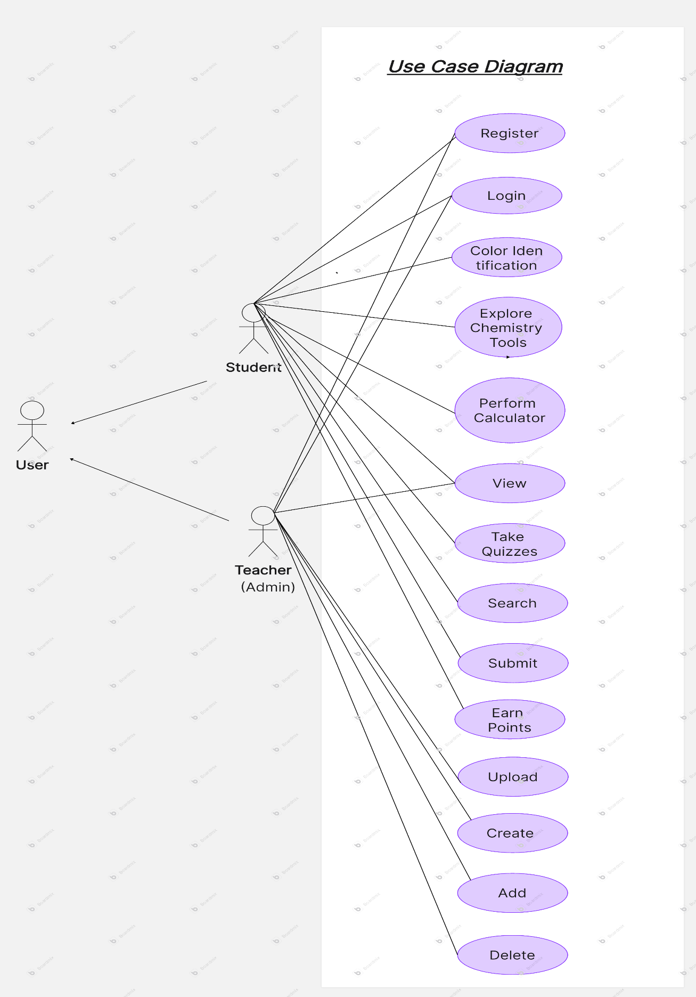

## **2.5 Drawbacks of the existing system**

Some drawbacks of using the current system for instruction -

1. Insufficient Interactivity

* Students are not effectively engaged by the current systems (such as books or static materials).
* Pupils struggle to comprehend abstract ideas like molecular connections and reaction mechanisms, as well as to picture intricate chemical structures.
* Interactive components that could improve comprehension, such tests, simulations, or 3D models, are lacking.

2. Limited Accessibility

* Access to resources is limited by the location and time constraints of traditional learning systems, such as classroom-based learning.
* Certain concepts may be difficult for students to understand if they do not have access to physical textbooks or lab equipment.
* Learning is hampered by a lack of access to current materials and resources, particularly in rural or underdeveloped locations.

3. Unchangeable Learning Paths

* All students in traditional systems are expected to learn at the same rate and use the same methodology, which is a one-size-fits-all approach.
* Personalized learning pathways are typically not supported, allowing students to concentrate on their areas of weakness or learn at their own speed.
* A dearth of gamified learning options or adaptive learning systems that can tailor each student's educational experience.

4. Absence of Real-Time Feedback

* Students who use traditional teaching techniques (textbooks or lectures in class) cannot get immediate feedback on their comprehension or errors.
* Particularly in difficult disciplines like chemistry, delayed feedback impairs students' ability to learn and fix mistakes promptly.
* The lack of interactive activities, automated tests, or gamification components that give pupils immediate feedback.

5. Absence of Practical Experiments

* Practical chemistry experiments rely significantly on specialized lab equipment or physical space, which not all students may have access to.
* Virtual simulations and interactive technologies that could enable students to perform safely, virtual chemical experiments are not available in current systems.
* Students lose out on interesting and interactive activities that could strengthen their grasp of chemistry ideas when gamification isn't used.

6. Limited Cooperation

* Collaboration among students is generally not facilitated by traditional learning approaches.
* Peer-to-peer learning is limited since there are few opportunities for group discussions, information sharing, or cooperative problem-solving.
* Absence of gamification elements that could encourage students to cooperate, such as cooperative challenges or team-based learning opportunities.

7. Absence of Data Monitoring

* It's possible that the existing systems can't monitor students' performance or progress over time.
* It is challenging to provide individualized help because teachers have few tools at their disposal to track each student's progress.
* There is no incentive or simple way to keep track of accomplishments, milestones, or progress without gamification elements like leaderboards or point systems.

8.Outdated or Incomplete Information

* Traditional educational systems frequently use antiquated or inadequate teaching resources to address contemporary learning requirements.
* Important learning resources like past test questions, guides, and interactive materials cannot be easily accessible or arranged.
* Dynamic content that can be updated often is lacking, particularly on digital platforms that facilitate gamification and interactive learning.

9. Lack of compatibility with mobile devices

* For students who would rather study on their smartphones or tablets, most current solutions are less convenient because they are primarily made for desktop computers.
* Students' ability to learn while on the go is restricted by a lack of mobile-friendly platforms, especially when attempting to connect with gamified or interactive chemistry content.

10. Concerns about Security and Privacy

* Traditional systems are vulnerable to privacy problems and security breaches, particularly those that use paper-based tools or outdated software.
* Student data is susceptible to unwanted access since appropriate data encryption and authentication are frequently lacking.
* If not used appropriately, gamification techniques could also reveal more privacy issues as digital learning platforms gain popularity.

11. Effects of Gamification (Resolving the Issues)

* Improved Interactivity - Learning becomes more dynamic when gamified components, such as tests and prizes, boost participation and aid in the visualization of difficult ideas.
* Better Accessibility - Students can learn on mobile devices at any time thanks to the accessibility of digital gamified systems.
* Personalized Learning Paths - With customizable challenges and performance-based rewards, gamification enables students to advance at their own speed.
* Instant Feedback - Through leaderboards, badges, and points, students receive immediate feedback that facilitates prompt correction and development.
* Simulated Hands-On Experimentation: By removing the constraints of real labs, virtual labs and simulations provide secure, interactive experiments.
* Collaboration and Social Learning - Gamification promotes group activities and team challenges, which promote cooperation and cooperative problem-solving.
* Data-Driven Progress Tracking - By using points and accomplishments to track progress, gamified systems offer insights for tailored assistance.
* Current, Interesting Content - Gamification ensures that content is interesting and up to date, and it is updated often to keep students interested.

Many of the shortcomings of conventional, non-interactive teaching methods can be addressed by incorporating gamification into the curriculum, which will increase student engagement, personalization, and effectiveness.

## **2.6 UI Design Development**

Home Page

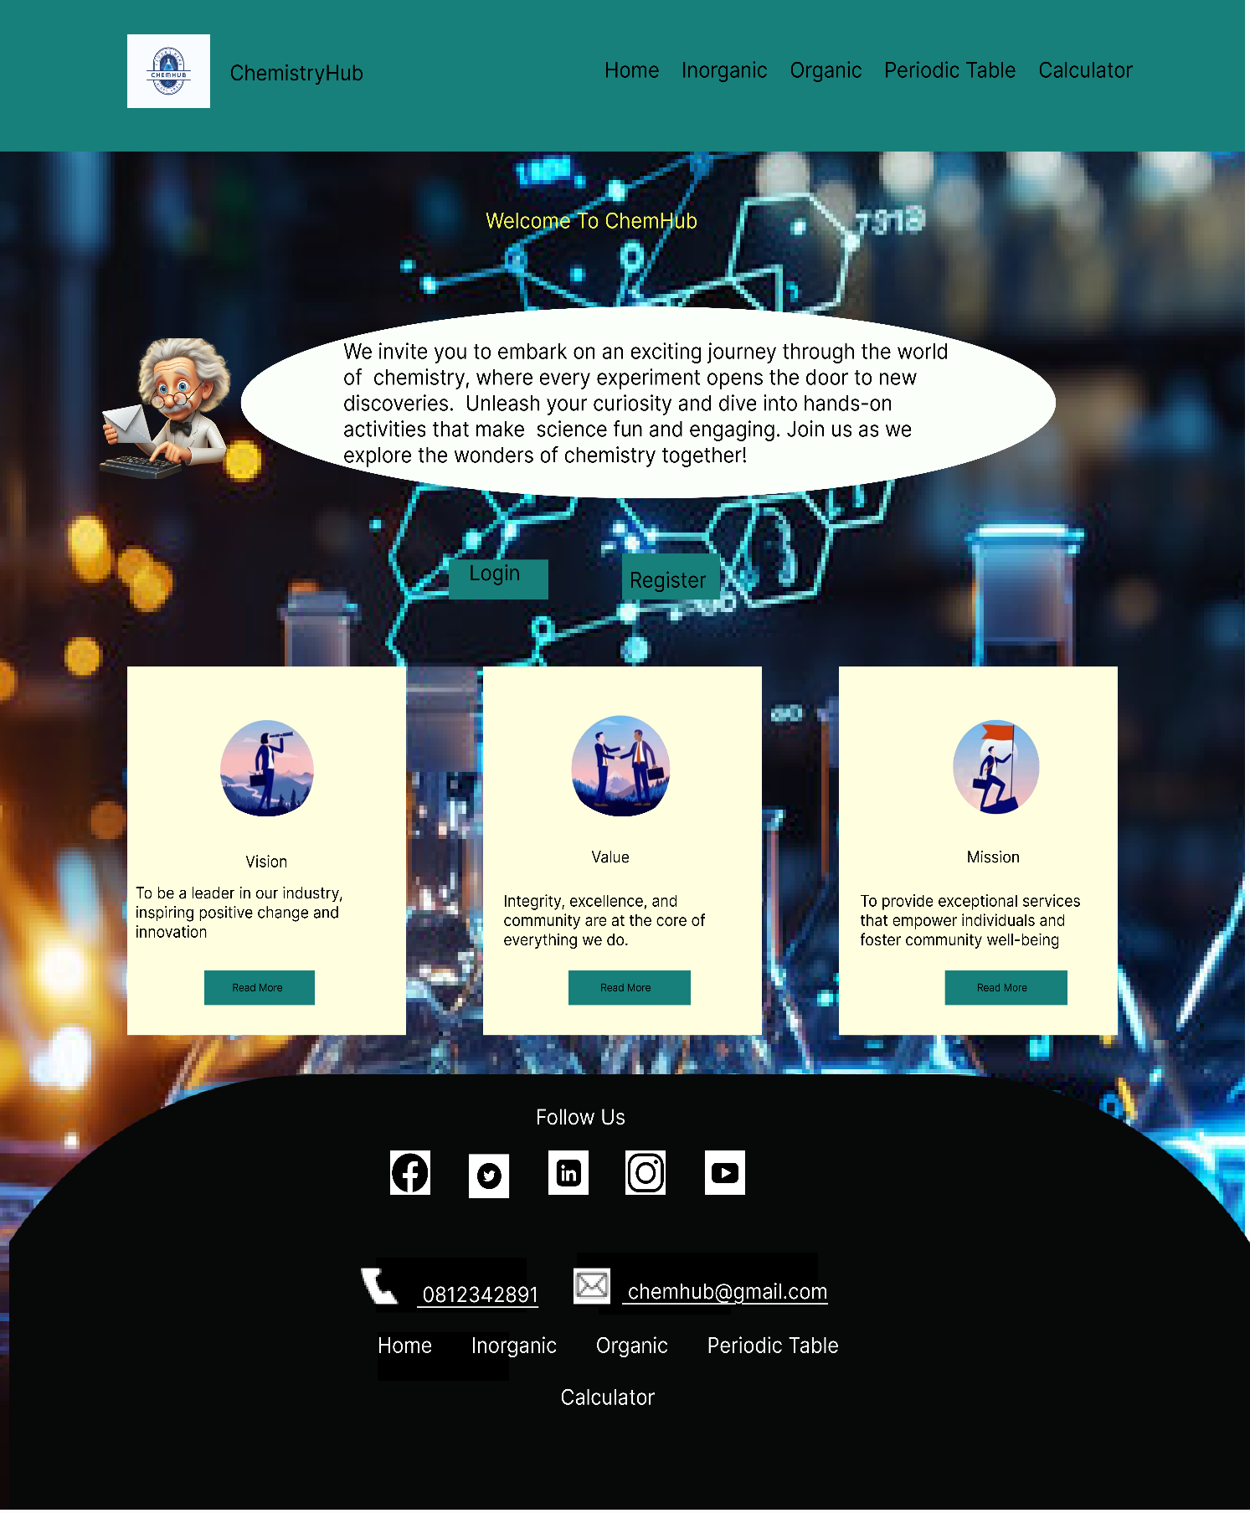

Inorganic Page

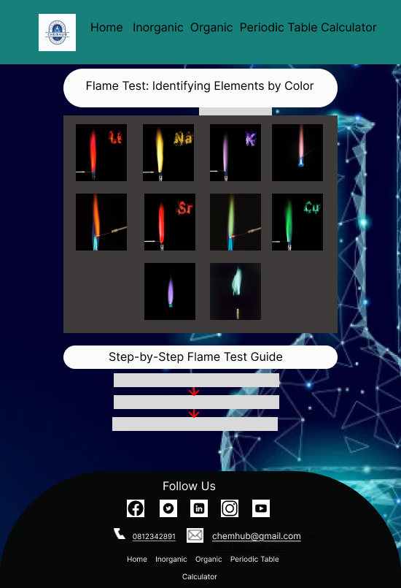

S block Page

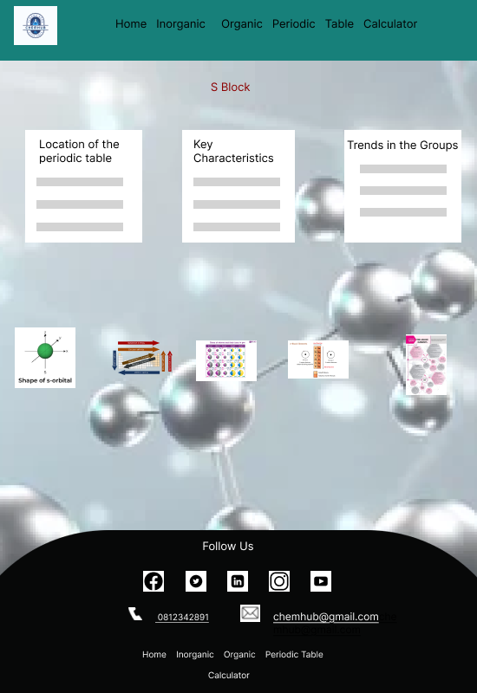

P block Page

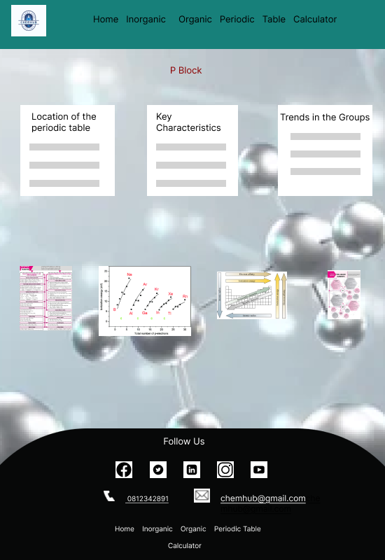

D block Page

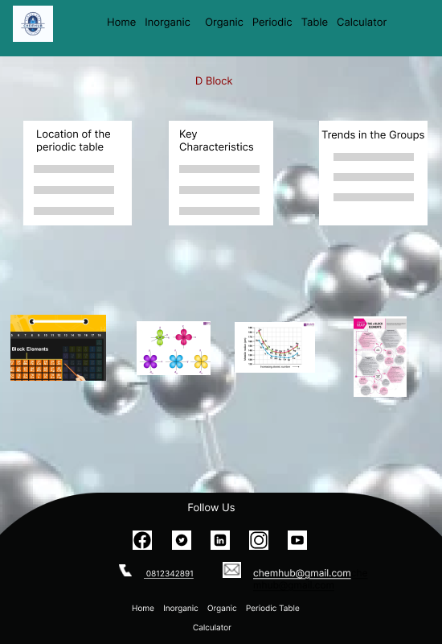

Block Page

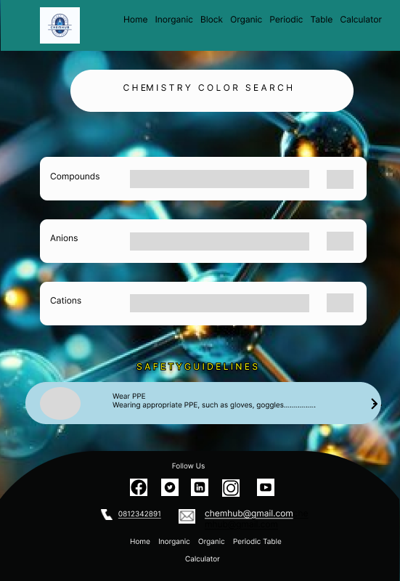

Organic Page

Periodic Table Page

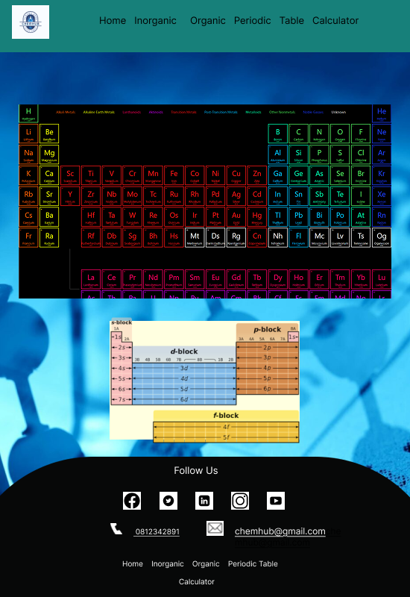

Calculator Page

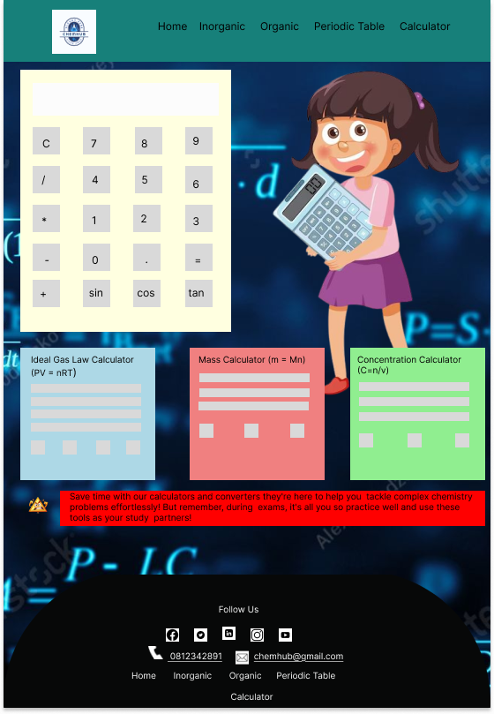

Login Page

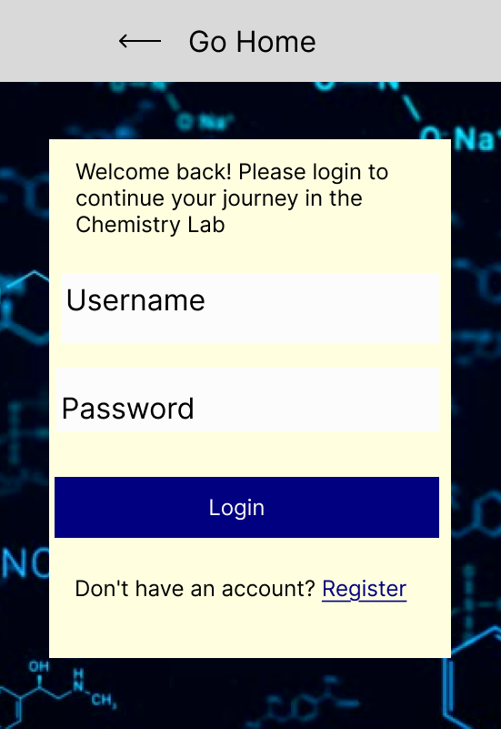

Register Page

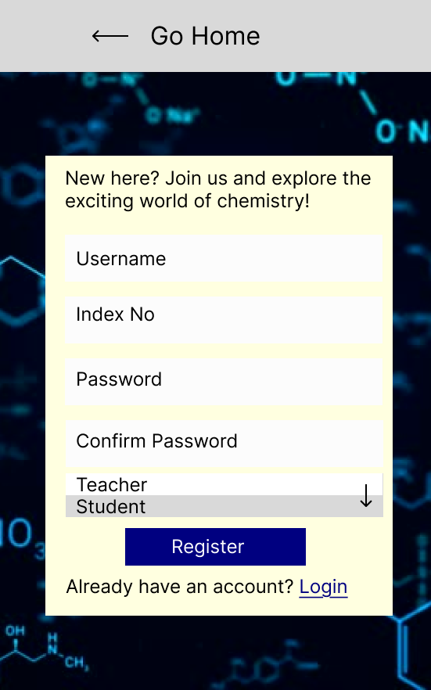

Frontend coding and UI design are about finished, and I'm working on the dashboard and gamification.

**Using Shneiderman's Eight Golden Rules in My User Interface Design**

1. Issues with the Original UI Design

Prior to using the Eight Golden Rules, I ran into the following problems –

* UI element inconsistency - Various buttons and font styles were applied to various screens.
* Complex navigation - Some features were hard for users to find.
* Absence of feedback unclear reactions to user input (such as button presses).
* Problems with error prevention- Absence of confirmation dialogs for important operations like data deletion

2. How I Overcame These Issues

I used the 8 Golden Rules to improve the UI design to address these problems –

* Aim for Regularity - Uniform button layouts, colors, and typefaces on all screens.  
   Kept the navigation styles consistent.
* Permit Regular Users to Utilize Shortcuts - Quick actions and keyboard shortcuts have been added for power users.
* Give insightful criticism - Gave immediate feedback (such as success messages upon form submission).  
   For lengthy processes, loading indicators were used.
* Create Conversations to Bring About Closure - Users see a confirmation message after finishing an action.
* Avoid Mistakes - Confirmation pop-ups for irreversible actions have been included.  
   Used input validation, such as making sure emails are formatted correctly.
* Encourage the Internal Control System - To provide users with a sense of control, actions were made predictable.  
   Enabled users to alter specific settings.
* Minimize the load on short-term memory - Forms that have been simplified by being divided into steps (multi-step forms).  
   Tooltips and labels were used to make functionality easier for users to understand.

3.In conclusion

I enhanced my UI design's usability and user experience by putting these ideas into practice. In line with UI/UX best practices, the design is now more user-friendly, consistent, and intuitive.

# **Chapter 03 - Requirements Specification**

## **Functional Requirement**

1. System for User Registration and Login

* Description - To access personalized content, users (teachers and students) should be able to sign up and log in.
* Features - User authentication (password and username).  
   Safe signup and login.  
   Feature for recovering passwords.

2. Guide to Flame Testing

* This guide explains how to detect elements using flame tests and flame color.
* Features - Multiple items include an interactive color chart.  
   A synopsis of responses and flame tests.

3. Color Search Tool for Chemistry

* The purpose of this search engine is to assist users in investigating various chemical compounds and their related colors.
* Features – Search box for entering chemical names and formulas.  
   Display of related colors for substances, mixtures, or processes.

4. Periodic Table Interactive

* The periodic table ought to be dynamic, presenting details on every element.
* Features - Information like the atomic number, atomic mass, and group/family are displayed when you click on any element.  
   The ability to see where each element is located on the periodic table.

5.Calculators for Science

* Students can use this set of calculators to help with important chemistry calculations.
* Qualities -  
   Perfect The relationship between pressure, volume, temperature, and moles can be calculated using the Gas Law Calculator.  
   Concentration Calculator - Provides comparable concentration formulas, molarity, and molality.  
   Trigonometric Calculator - Solves equations involving angles, trigonometry, and trig ratios.

6. Gallery of Organic Compound Images

* Description - An image gallery featuring close-ups of the main organic components.
* Features - Organic compound thumbnails.  
   For high-resolution views of chemical structures, modal pictures zoom in.  
   Brief explanations of every chemical.

7. Interactive Test Platform

* The purpose of these quizzes is to assess students' knowledge of chemical concepts.
* Features - True/false, multiple-choice, and short-answer questions.  
   Every question is answered instantly.  
   The ability to view clarifications and answers after completing the test.

8. Pages S, P, and D

* S-Block Components - Details about S-block element placement, reactivity trends, and salient features.
* P-Block Components - Position and attributes of P-block elements, such as trends and images.
* D-Block Components - D-block element locations with ionization energy and use trends.

9. Adaptive Footer and Navbar

* The navigation bars and footer are responsive, meaning they adjust to the size of the screen.
* Features - Simple navigation to the primary pages (Gallery, Calculators, Periodic Table, etc.).  
   Uniform user interface throughout the website.  
   Tablet and smartphone compatibility.

10. Previous Assignments, Guides, and Question Bank (Upcoming Implementation)

* The resources section offers a question bank, tutorial materials, and previous exam papers.
* Future features - Access to documents and instructional videos.  
   A collection of self-testing practice questions.

11. Dashboard for Teachers

* Description - A dashboard that lets teachers monitor progress, control student learning, and keep tabs on performance.
* Features - A summary of learning activities, quiz scores, and student progress.  
   Assignment of tasks, tests, and badges is an option.  
   Track student accomplishments and leaderboard positions in real time.  
   Students receive immediate feedback on their performance and opportunities for development.

12. Gamification for Students

* Description - Engaging game-like elements to enhance student participation and motivation.
* Features - Points System: Earn points for completing quizzes, interactive exercises, and learning milestones.

Badges & Achievements - Unlock badges for mastering concepts, consistent participation, and high quiz scores.

Progress Tracking **-** A visual representation of progress through different chemistry topics.

Challenge Mode - Compete in timed quizzes or problem-solving challenges with classmates.

Streak Rewards - Encourage daily engagement by rewarding students for consecutive learning days.

Interactive Competitions - Participate in chemistry trivia or collaborative problem-solving tasks with peers.

Custom Avatars & Themes **-** Personalize user profiles based on progress and achievements.

These gamification features will make learning chemistry more engaging and encourage students to actively participate in the interactive chemistry web application.

## **3.2 Non-Functional Requirements**

1. Usability

* The web application should be simple to use and intuitive to the students and educators.
* The interface should be simplistic in understanding, with little learning required for fresh users.
* The application should support multiple languages to provide gates to further usability.

2. Performance

* The application should load within 3 seconds or less to ensure a smooth user experience.
* It should handle simultaneous user requests efficiently, particularly during peak usage periods, to ensure response times.
* The interactive capabilities (e.g., periodic table, calculators, quizzes) should update and respond in real time to user input.

3. Scalability

* The system should be able to scale up and accommodate increased numbers of users (students, teachers, future chemistry professionals) without performance loss.
* The system should be capable of adding new features like past papers, tutorials, or professional content whenever needed in subsequent additions.

4. Reliability

* The web app should not crash or halt abruptly.
* The system should have errors in handling mechanisms to handle possible failures (e.g., invalid input, incomplete information).
* Regular backups need to be performed to support data integrity and recoverability at the time of failure.

5. Security

* The application needs to use secure user authentication through JWT tokens or OAuth to protect user data.
* Sensitive user data, such as passwords and personal data, need to be encrypted in transit and when stored.
* User sessions should expire automatically after a specified period of inactivity to prevent unauthorized use.
* The application should have firewall and SSL encryption to prevent potential cyber-attacks.

6. Compatibility

* The application should be compatible with major browsers (Chrome, Firefox, Safari, Edge).
* It must be responsive and accessible on various devices, like desktops, laptops, tablets, and smartphones, employing a mobile-first design approach.
* The application should be completely operational on Windows, macOS, and Linux operating systems.

7. Accessibility

* The application should comply with WCAG 2.1 guidelines so that it is accessible to disabled users.
* It should support features such as screen readers and keyboard navigation for visually or motor-impaired users.
* All interactive items (buttons, forms, etc.) should have proper contrast, text size, and alt text for images.

8. Maintainability

* The codebase of the system should be compliant with the best practices and well-documented for easy maintenance and future enhancements.
* It must be module-based, i.e., each feature developed as a standalone module so that it can be easily maintained and patched.
* The implementers must be working under an open version control system such as Git so that everyone can monitor changes and work in harmony.

9. Data Privacy and Compliance

* The web app must comply with relevant data privacy laws (e.g., GDPR, CCPA) to protect users' data.
* The application must allow users to manage their own privacy settings and see controlling data they provide (e.g., data collection opt-out or customized content).
* Users must be able to delete their data from the site when they want.

10. Internationalization

* The platform must facilitate seamless translation and localization to different languages for global access.
* Date and number formats should be region-specific (e.g., DD/MM/YYYY vs MM/DD/YYYY).

11. Interoperability

* The app should be interactable with other learning programs, platforms, or databases if the need arises (e.g., integration of past papers, external quizzes).
* Extensions in the future (e.g., expert chemistry content, compatibility with laboratory equipment) need to be merely interoperable with existing systems.

These non-functional requirements establish the performance, security, usability, and other quality characteristics your project must meet to guarantee that it serves the intended target audience effectively and can be extended in the future.

## **3.3 Software Requirements**

1. Development Environment

* Operating System - Windows 10/11, macOS, or Linux
* Programming Languages -
  + - Frontend - HTML, CSS, JavaScript (Svelte, TypeScript)
    - Backend - Java (Spring Boot)
    - Database – MongoDB / My SQL

2. Frameworks & Libraries

* Frontend - Angular / SvelteKit, Tailwind CSS
* Backend - Spring Boot, Spring Security
* Database Management - MongoDB Atlas (Cloud) / My SQL Server
* WebSockets for real-time leaderboards and Phaser.js for interactive tests and challenges are examples of gamification.
* Analytics using Chart.js DataTables.js is used to manage student progress, and FullCalendar.js is used for scheduling.

3. Server & Hosting

* Hosting - Firebase, Vercel, or AWS
* Web Server - Apache Tomcat (for Java Spring Boot)

4. Development Tools

* Version Control - Git & GitHub
* IDE - VS Code (Frontend), IntelliJ IDEA or Eclipse (Backend)
* API Testing - Postman
* Design & Prototyping - Figma
* Package Manager: NPM or Yarn
* JWT for authentication in game progress tracking, Firebase Firestore for real-time score tracking
* For sophisticated data visualization, use Google Charts or D3.js; for notifications, use Firebase Cloud Messaging.

These software specifications ensure smooth development and deployment of your interactive chemistry web application.

# **Chapter 04 Feasibility Study**

## **4.1 Operational Feasibility**

Operational feasibility analyzes if the interactive chemistry web application might be implemented into the daily learning process of students and teachers with ease.

Key Considerations:

1. User Acceptance

* The application is designed for students and teachers, hence user-oriented and relevant to the education of chemistry.
* Interactive features like quizzes, discovery of the periodic table, and chemistry calculators enhance interaction.
* Leaderboards, accomplishment badges, and progress monitoring are examples of gamification features that enhance learning and inspire students.

2. Ease of Use

* A clean interface with a responsive design allows for effortless navigation between desktops and mobile devices.
* Minimal technical knowledge is required to use the application.
* The mechanics of gamification are simple, and little technical expertise is needed.

3. Integration into Educational Institutions

* It can be used in classrooms, labs, and at home for self-paced learning.
* Supports teachers in delivering visual and interactive chemistry lessons.
* Information about quiz results, student progress, and engagement levels is available on the teacher dashboard.

4. Security & Accessibility

* Secure login and authentication for students and teachers.
* Ensures data privacy while providing access to relevant educational resources.
* Because gamification components are adaptable, educators can create challenges that complement curriculum objectives.

5. Future Scalability

* It can be expanded to include chemistry professionals, past papers, practical, and tutes.
* Enables addition of more content like S, P, and D block elements, trends, and key features.
* To boost engagement, gamification techniques can develop to include reward-based learning platforms, chemical contests, and multiplayer challenges.
* To assist teachers in assessing student achievement, the system can incorporate analytics and real-time progress tracking.

The system is operational feasible in the sense that it is easy to operate, satisfies the educational needs, and enhances the learning process for chemistry teachers and students.

## **4.2 Technical Feasibility**

Technical feasibility evaluates whether the interactive chemistry web application can be developed and maintained using the available technologies, tools, and infrastructure.

Key Considerations -

1. Technology Stack Compatibility

* Frontend - HTML, CSS, JavaScript (Ensures responsive and interactive UI).
* Backend - Java (Handles authentication, data processing, and logic).
* Database - MongoDB (Stores user data, quiz results, and chemistry resources).
* Hosting & Deployment - Cloud-based servers or local hosting with scalability options.

2. System Performance & Scalability

* Optimized database queries ensure fast data retrieval.
* Supports multiple users simultaneously without performance issues.
* Future scalability allows integration of additional features (e.g., past papers, tutes, practical).
* Fast data retrieval and real-time updates for gamification components (such as leaderboards and progress monitoring) are guaranteed via optimized database queries.

3. Networking & Connectivity

* Requires an active internet connection for accessing real-time content and user authentication.
* Supports cloud-based storage for enhanced performance and availability.

4. Security & Data Protection

* Implements secure login and authentication for students and teachers.
* Protects sensitive data, such as quiz results, student progress, and dashboard statistics, by implementing data encryption.
* Comply with the best security procedures to shield gamified learning modules from data leaks and unwanted access.

5. Compatibility & Device Support

* Works on desktop, tablets, and mobile devices with responsive design.
* Compatible with modern web browsers like Chrome, Firefox, Safari, and Edge.

6. Features of Gamification

* Leaderboards to monitor the best quiz and chemistry challenge performers.
* Incentives and achievement badges for reaching learning objectives.
* Unlockable levels and visual progress bars are features of real-time progress monitoring.

7. Dashboard Features

* Offers data on quiz results, engagement patterns, and student participation.
* Enables instructors to design and oversee chemical tasks, tests, and challenges.
* Shows current leaderboard standings and student progress reports.

The project is technically feasible as it utilizes widely used, scalable, and secure technologies to deliver a smooth, interactive, and efficient learning experience for chemistry students and teachers.

# **Chapter 05 System Architecture**

## **5.1 Class Diagram of Proposed System**

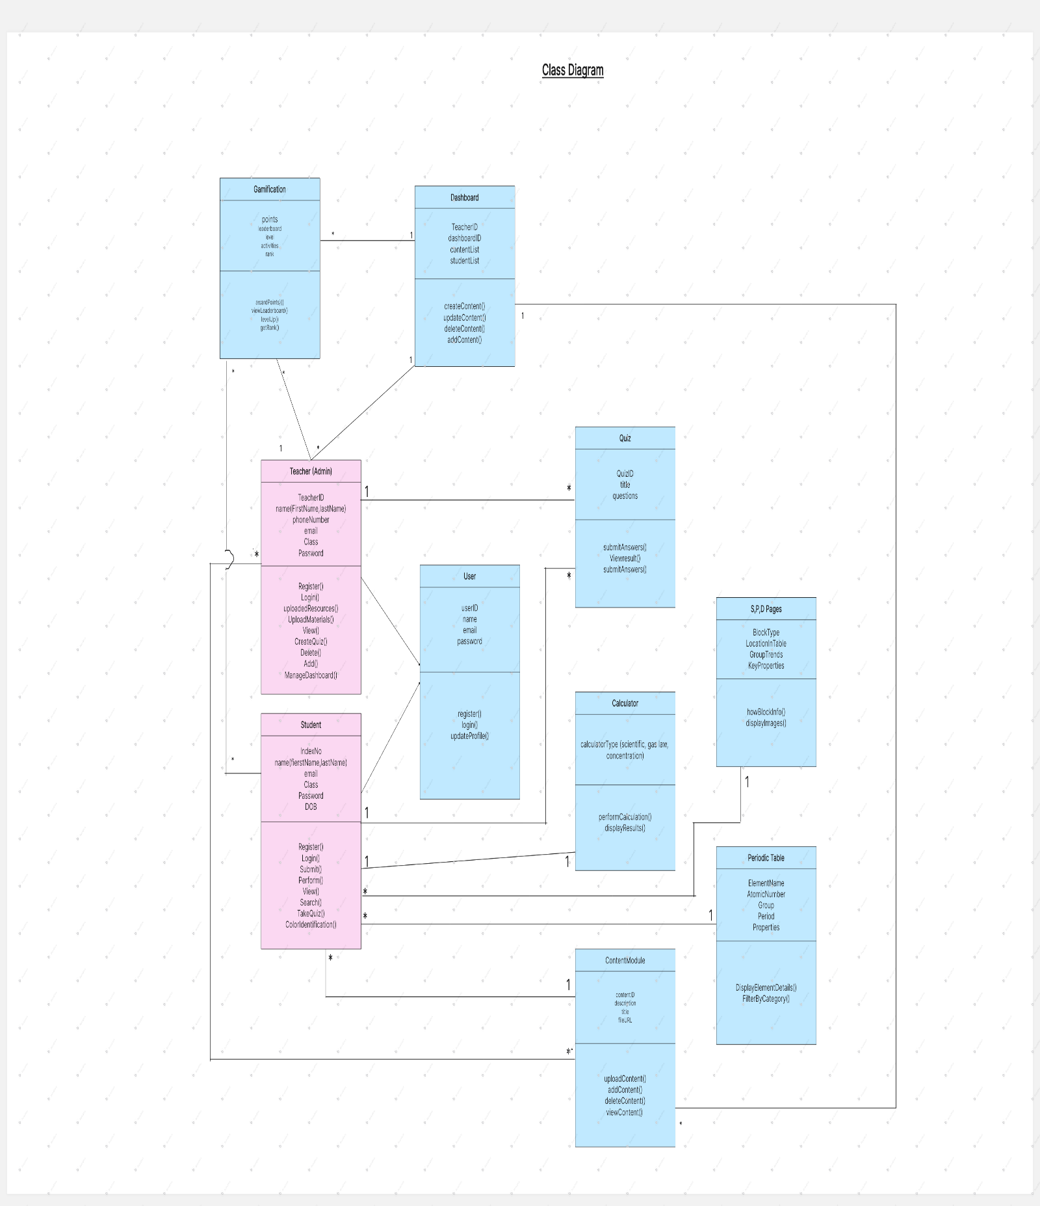

## **5.2 ER Diagram**

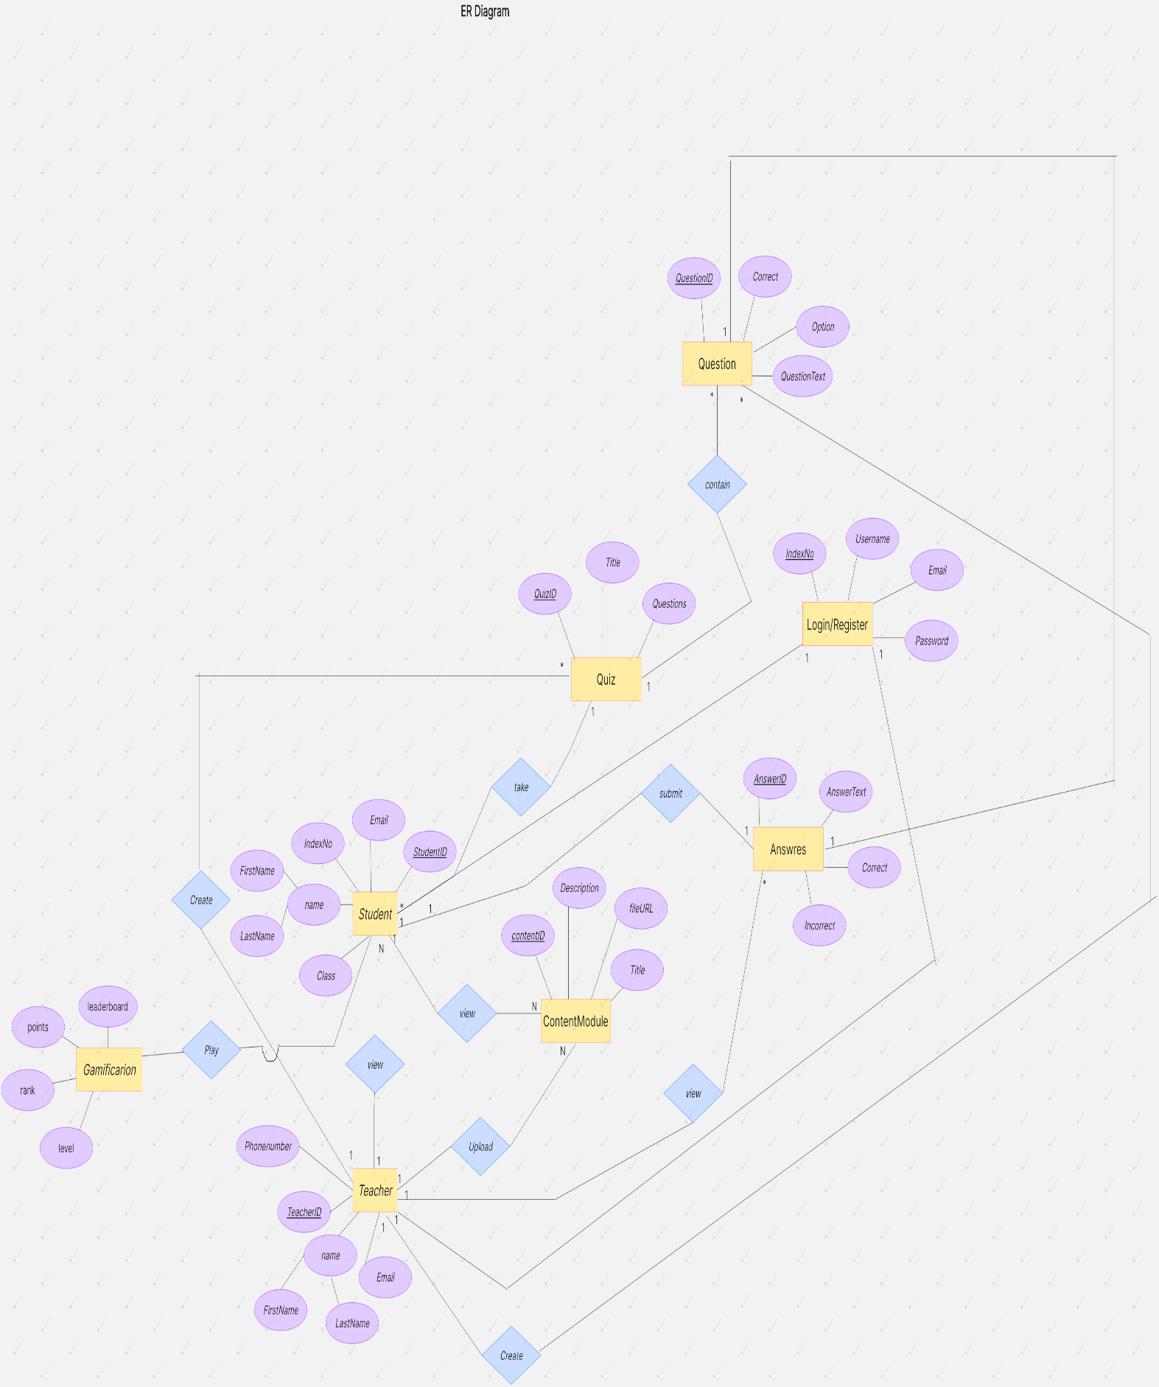

## **5.3 High-level Architectural Diagram**

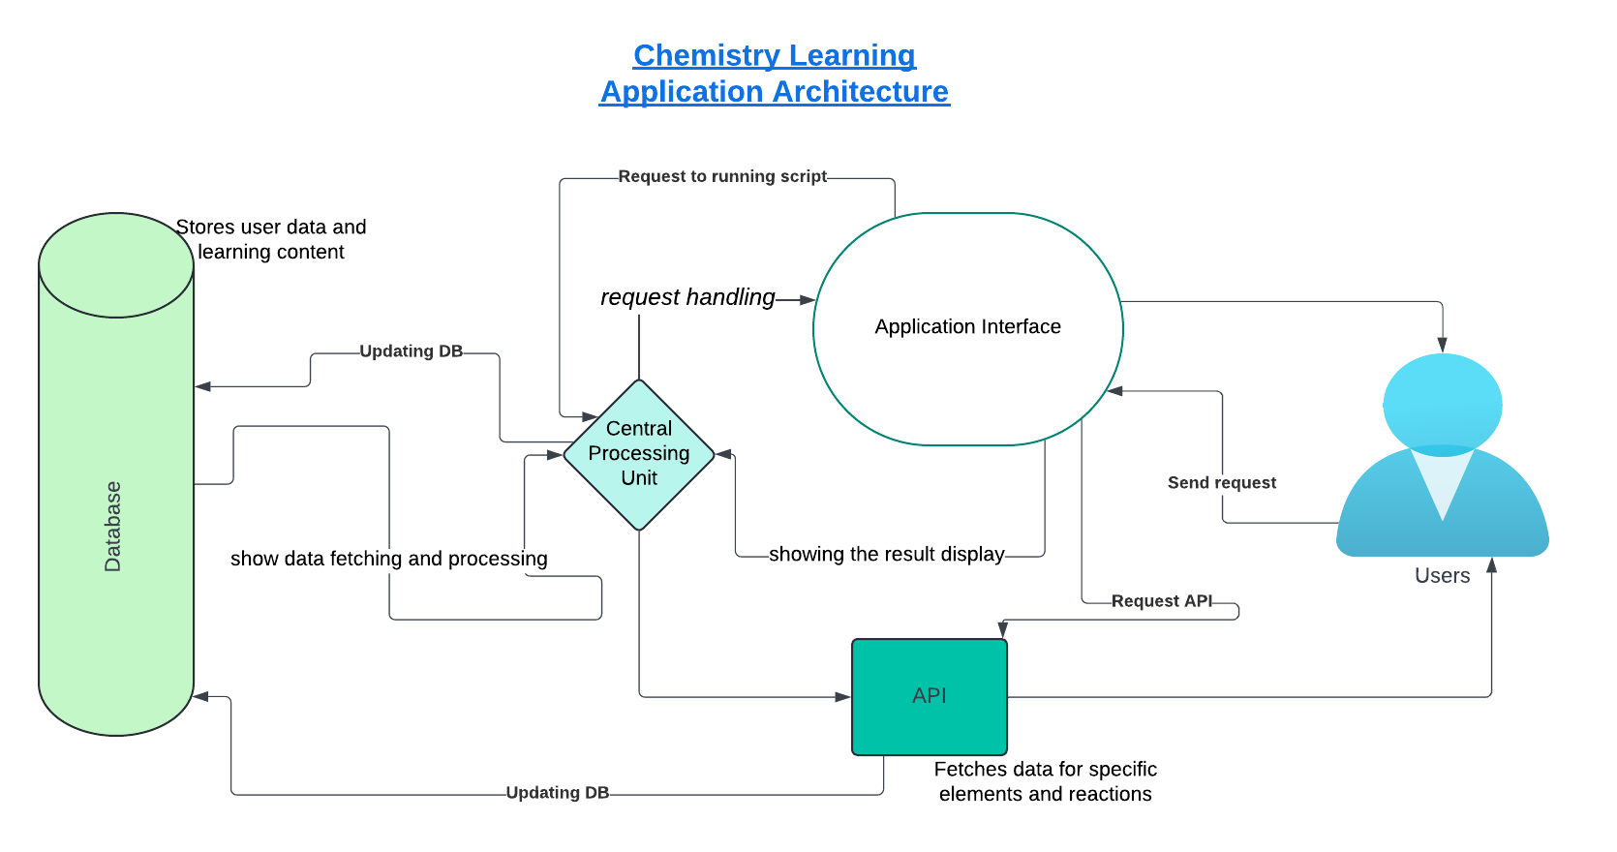

# **Chapter 06 - Development Tools and Technologies**

## **6.1 Development Methodology**

The development of the Interactive Chemistry Web Application follows the Agile methodology. Agile allows adaptive development, iterative improvements, and continuous feedback, which makes it an ideal approach for an education platform.

Key Aspects of Agile Methodology in This Project –

* Iterative Development - The system is constructed in multiple sprints, with features like the Dashboard, Calculators, S/P/D Block pages, Periodic Table, and Gamification features being produced and tested one after the other.
* Constant Feedback - Teachers, students, and other users' feedback guarantees that the application meets user demands, enhancing user engagement and educational material.
* Flexibility & Adaptability - Modifications can be made at any stage of the development process to improve the interaction, functionality, and usability of the application. This includes modifying the dashboard's features and gamified aspects in response to user feedback.
* Faster Deployment - To enable early testing and improvement, components such as the interactive Dashboard, Calculators, S/P/D Block pages, Periodic Table, and gamified learning features are created in tiny, manageable releases.
* Testing in Every Sprint - To guarantee excellent performance, security, and usability, every sprint includes thorough testing. While the Dashboard is assessed for usability and data presentation efficacy, gamification components are checked for user engagement.

## **6.2 Programming Languages and Tools**

The development of the Interactive Chemistry Web Application involves the following programming languages and tools.

1. Development of Backends  
 Java (Spring Boot) is the programming language used to manage database operations, server-side logic, and the backend procedures for the dashboard and gamified features.  
 Database - MongoDB, a NoSQL database used to store user information, content, and resources pertaining to chemistry, as well as to monitor user progress in gamified activities.  
  
2. Frontend development uses HTML, CSS, and JavaScript to structure, style, and create interactivity. This includes gamification features like achievements and leaderboards as well as the dashboard's user interface.  
  
3. Security and Authentication  
 For administrators, instructors, and students to access the dashboard and gamified features, safe authentication is ensured by JWT (JSON Web Token).  
 BCrypt - To secure user data, employ password encryption.

4. Frameworks & Tools  
 Spring Boot - This backend framework manages database interfaces, APIs, and supports real-time updates for dashboard analytics and gamification elements.  
 Node.js and Express.js - These frameworks are used to manage API calls, real-time interactions, and the updating of dynamic dashboard material, such as user scores and progress.  
 Bootstrap/Tailwind CSS - This framework ensures that the dashboard and gamified elements are responsive and available on all devices.  
  
5. Other Technologies  
 Cloud storage (Firebase/AWS S3): Used to store chemistry-related papers, photos, and media content for the dashboard (e.g., visual analytics) and gamification (e.g., badges, prizes).  
 Real-time quiz interactions, discussions, and dashboard updates, such as live score tracking, leaderboard rankings, and event notifications, are made possible via WebSocket.

## **6.3 Third Party Components and Libraries**

01. Frontend Frameworks & Libraries

* React.js - For developing dynamic and interactive user interfaces, particularly for the interactive dashboard, gamified components (such as achievements and quizzes), and the periodic table.
* Chart.js or D3.js - Used for periodic table property trend charts, chemical data charting, and dashboard graphical analytics, such as user ranks and progress tracking.
* Bootstrap/Tailwind CSS - To make a mobile-first, responsive user interface, making sure the dashboard and gamified features work and look well on all devices.
* jQuery - This is useful if minimal DOM manipulation is required, particularly for older browser compatibility while preserving gamification features and dynamic dashboard content refreshes.

02. Tools & Libraries for the Backend

* Spring Boot - An effective platform for creating Java-based applications that includes database integrations, security modules, gamification logic (e.g., badges, points), and APIs.
* Spring Security - For user access control, secure login, and authentication and authorization management for the gamified features as well as the core application.
* JWT (JSON Web Token) - Provides safe access to gamified elements and tailored content on the dashboard using token-based authentication.
* To store and retrieve user data, chemistry-related resources, and gamification statistics (such as scores and achievements), one needs the MongoDB Driver (MongoDB Java Driver).
* BCrypt - This tool ensures user privacy and security when they access gamified features and dashboard data by hashing and securely storing passwords.

03. Libraries for Real-time Communication

* Socket.IO to incorporate real-time functionalities like interactive forums, live quizzes, and dashboard updates like leaderboards, event notifications, and live score monitoring.

04. Libraries for Image Processing and Uploading

* High-quality photographs of chemical compounds, periodic tables, experiment photos, and gamified visual elements (such as badges and prizes) can be stored and served using Cloudinary or Firebase Storage.
* Dropzone.js - This allows users to drag and drop files, especially chemistry-related files, pictures, and other files for gamification or study resources.

05. Testing Tools & Libraries

* Jest - For testing JavaScript (API calls, gamified user interface elements, and React components).
* Junit - This tool is used to unit test the Java backend code, guaranteeing that the gamified features and instructional content work as intended.
* Mockito - This Java mock test tool is helpful for testing database operations, services, and game-related functionality (such as badge unlocking or point awarding).

## **6.4 Algorithms**

1. Chemistry Color Tool Search Algorithm

* Objective - To recognize chemicals by the color of their flame tests.
* Method -
  + - Linear Search - Since you are provided with a list of chemicals along with their respective flame colors, a linear search can be easily implemented to find a match between data and input.
    - Binary Search (optional) - If the data is large and sorted (e.g., sorted by flame colors or chemical names), you can carry out a binary search to improve search efficiency.
* Gamification - When users correctly identify chemicals based on their flame color, they can earn points or badges that will be shown on their dashboard as part of their overall score.

2. Quiz Scoring Algorithm

* Purpose - To score and evaluate student quizzes according to user input.
* Gamification: Every right response adds to a user's score, which is updated in real time on their dashboard. Users are able to view their progress, accomplishments, and rating over time.
* Approach -
  + - Grading Algorithm- The application will compute the total score by comparing the student's answer to every question to the correct answer and then appending the corresponding points to the total score.
    - Example

|  |
| --- |
| let score = 0;  for (let i = 0; i < quizQuestions.length; i++) {  if (userAnswer[i] === correctAnswers[i]) {  score++;  }  }  return score; |

3. Periodic Table Search Algorithm

* Function - To search and filter elements in the periodic table according to different properties (e.g., group, period, type of element).
* Strategy -
  + - Filter Algorithm: Based on user input (e.g., group or period), you can filter the list of elements according to the input parameter. This can be done either through simple filtering or sorting according to the properties of each element.
    - Example: Filter by group

|  |
| --- |
| let filteredElements = periodicTable.filter(element => element. group === userInputGroup); |

4. Algorithm for Calculation of Concentration

* Purpose - Calculate the concentration of a solution from user input (e.g., molarity, volume, or quantity of solute).
* Method - Formula for calculation of concentration is typically
  + - C=n/V,
    - C is the concentration,
    - n is the number of moles,
    - V is the volume.
    - Algorithm Steps - Program will ask the user for inputs required (number of moles, volume) and use the formula to compute the concentration.
    - Example

|  |
| --- |
| let concentration = moles / volume; |

5. User Authentication Security Algorithm

* Purpose - Securely store and check user credentials in the login and registration process.
* Approach -
  + - Password Hashing - Hash passwords using an algorithm such as bcrypt prior to storing in the database.
    - JWT Authentication - A JSON Web Token (JWT) may be created upon successful login by a user to enable secure sessions for subsequent interactions.

6. Image Zooming Algorithm for Modals

* Purpose - To provide a better view of images in the image gallery (e.g., molecular structures, chemical compounds).
* Approach -
  + - Zooming Effect: Implement an algorithm to magnify the image on click or hover, possibly using CSS enlargement or JavaScript libraries like Lightbox or Fancybox for image zooming.

7. Data Validation Algorithm for User Input

* Purpose - To make sure inputs from the user (i.e., in the periodic table search, login form, or quiz answers) are valid prior to processing.
* Approach -
  + - regular expressions (regex) or JavaScript validation functions to confirm the input format is valid (e.g., valid email address, strong password).

Key Considerations for Algorithms

* Efficiency - Simplify algorithms as needed, especially when managing big data sets (such as periodic table data, quiz questions, or chemistry databases), to guarantee quick response times for consumers interacting with gamified features or accessing the dashboard.
* Security- Prevent unwanted access to algorithms that handle user-specific data (passwords, personal information, etc.), particularly when handling user accounts and sensitive data that is shown on the dashboard.
* Accuracy - To guarantee that gamified scores, badges, and leaderboard rankings are computed and shown appropriately, make sure that any algorithms that rely on calculations, such concentration and quiz grading, are exact and accurate.

Can utilize these algorithms to automate the core functionality of your Interactive Chemistry Web Application and deliver seamless, efficient, and secure interactions for the users.

# **Chapter 07 - Discussion**

## **Summary of the Interim Report**

The work completed so far on the Interactive Chemistry Web Application project is shown in the interim report. The report offers an overview of the project's requirements, strategy, use-case diagrams, system analysis, goals, and objectives. There is discussion of the application's main features, which include the thorough periodic table, quiz, chemical calculators, and color identification for flame tests. The paper also presents gamification elements that improve user engagement, like badges, rankings, and achievement points. The user interface, which is intended to include a dashboard that displays user progress, accomplishments, and scores, data collection, and hardware/software requirements are all covered in the study.

## **Summary of the Report**

The creation of a web-based platform to support educators and learners in chemistry instruction is the main topic of this paper. Interactive features in the system include quizzes, chemical calculators, color identification for flame tests, and the periodic table. With ongoing input from educators, learners, and experts, the application is based on a user-centered design philosophy and utilizes contemporary web technologies. To improve the learning process, new gamification features have been added to the system, such as leaderboards, challenges, and badges. The dashboard will function as a customized area where users may monitor their overall progress, accomplishments, and scores. Technical information about the system's architecture, functionality, and future expansion plans to add professional-level content for advanced students are also included in the paper**.**

## **Challenges Faced**

Several obstacles have been faced throughout the application's development

* User involvement - Providing comprehensive information that satisfies educational needs while preserving a high level of student involvement. A key tactic to boost engagement has been the incorporation of gamification elements such as leaderboards, challenges, and quizzes with rewards.
* Getting current and accurate chemical information for quizzes, reactions, and the periodic table is known as data accuracy. Making sure quiz answers are accurate and that instructional materials are current and trustworthy are additional challenges.
* Usability - Creating an interface that is easy to use and enjoyable for both educators and learners while striking a balance between the requirement for a straightforward layout and feature-rich information. The gamification elements and dashboard contribute to the experience's increased visual appeal and engagement.
* Security and Privacy - It's critical to make sure user data is secure, particularly for features like quizzes and login credentials. Strong authentication procedures, encryption for private data, and compliance with data protection laws are all included in the system.

## **Future Plans**

* Several significant improvements will be the main emphasis of the project's future development
* Integrating Chemistry Professionals - Including content of a professional caliber, including in-depth chemical themes, lab procedures, previous test papers, and practical. Expert-level tests and challenges that can be monitored via the dashboard will also be part of this.
* Mobile Application - To improve accessibility for teachers and students on various platforms, a mobile version of the application is being developed. To provide comparable experience across platforms, the mobile app will have a dashboard design that is similar for tracking accomplishments and progress.
* Stronger security features, such as improved user authentication, encryption of sensitive data, and adherence to data protection laws, are examples of improved security. The dashboard will give users clear information about the security of their user accounts, giving them peace of mind.
* Integration of User Feedback - Using input from instructors, students, and aspiring professionals to continuously improve the platform. To improve the dashboard experience and platform functionality overall, user recommendations for additional challenges, gaming features, and instructional resources will be integrated.

# **References**

<https://files.eric.ed.gov/fulltext/EJ1262695.pdf>

<https://www.researchgate.net/publication/380734414_The_Impact_of_Digital_Tools_and_Online_Learning_Platforms_on_Higher_Education_Learning_Outcomes>

<https://www.researchgate.net/publication/369010403_The_Impact_of_Technology_on_Education_A_Case_Study_of_Schools>

<https://pubs.acs.org/doi/epdf/10.1021/acs.chemrev.8b00020?ref=article_openPDF>

<https://pubs.acs.org/doi/10.1021/acs.chemrev.8b00020>

<https://files.eric.ed.gov/fulltext/ED624407.pdf>

<https://edu.rsc.org/download?ac=517132>

<https://pubs.rsc.org/en/content/getauthorversionpdf/c4rp00104d>

<https://research.bond.edu.au/en/publications/enhancing-chemistry-education-through-technology-enhanced-learnin>

<https://scholar.google.com/scholar?hl=en&as_sdt=0%2C5&q=research+papers+in+AL+chemistry&oq=C>